**Lab Practical #02:**

Study of different types of network cables & connectors and practically implement the cross-wired cable and straight through cable using crimping tool.

**Practical Assignment #02:**

1. List various networks cable and connectors. Also, write short description.
2. Give cross-wired cable and straight through cable diagram (Color Code wise).

## List various networks cable and connectors. Also, write short description.

1. **Twisted Pair Cable:**
   * Network Cable Type: Guided
   * **Description:**
   * separately insulated.
   * Twisted together.
   * It is widely used in different kind of data and voice infrastructure.
   * The use of two wire twisted together helps to reduce crosstalk and electromagnetic induction
   * Two types of twisted pair cable:
2. **UTP (Unshielded twisted pair)**

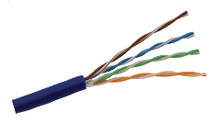 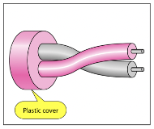

* Ordinary telephone wires
* Less expensive
* We community against noise interferences
* Most use in two categories: Cat-3 & Cat-5
* Used in laboratory



1. **STP (shielded twisted pair)**

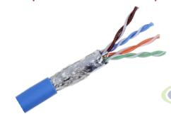 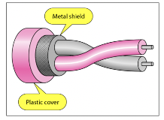

* An extra metallic shield on each pair
* Relatively more expensive
* Better performance then UTP
* Used in exterior network(outside of building)

1. **Coaxial Cable:**
   * Network Cable Type: Guided
   * **Description:**

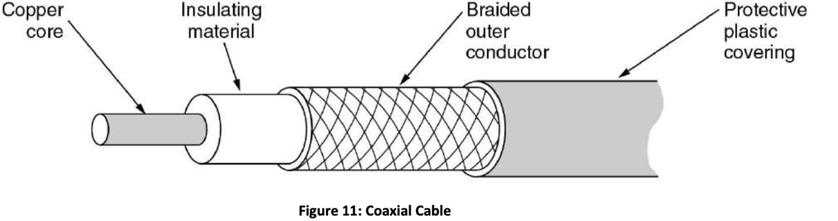

* + Open conductor is braided shielded.
  + Inner conductor is solid metal.
  + Separated by insulating material, and whole covered by plastic cover.
  + Used in television, long distance telephone transmission.
  + Hi bandwidth an excellent voice immunity.

1. **Fiber Optic Cable:**
   * Network Cable Type: Guided
   * **Description:**

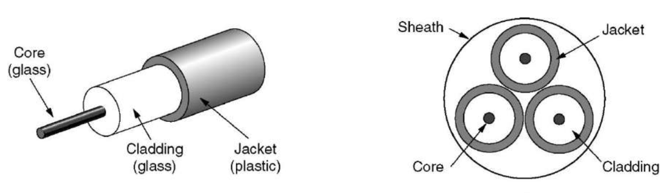

* + A Fiber-Optic cable is made of glass or plastic and transmit signals in form of lights.
  + Light travel in straight line as long as it is moving through a single uniform substance.
  + It is surrounded by cladding of less dense glass or plastic so, difference in density of two materials must be such that a beam of light moving through the core is reflected off the cladding instead of being reflected into it.
  + It is you reflection to guide light through a channel.
  + Small size and weight
  + Used in high bandwidth network
  + I data rate and lower attenuation.

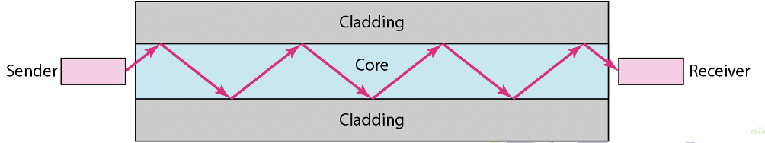

1. **RJ45 Connector**

* **Description:**

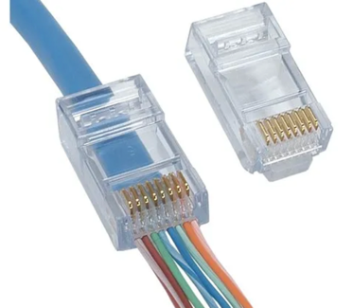 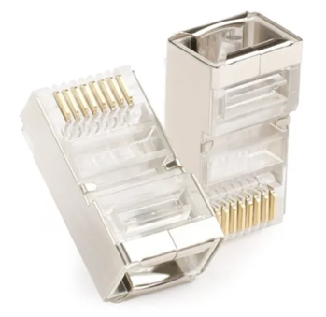

* + It is one of the most used networking connector in network world.
  + Made by plastic.
  + Larger than a classical telephone connector RJ11.
  + RJ45 is the connector of UTP and STP type cables.
  + With this connectors we can connect the cable between any two network devices, to routers, to switches, firewalls.

1. **Coaxial Cable Connectors**

* **Description:**
  + Coaxial cable connectors are used to connect cables to other devices and maintain the cable’s shielding.
  + There are two distinct connector styles – known as male and female. Male connectors have metals pin which protrude from the centre and female connectors have a recessed hole to receive the pin.
  + Here are some of the most common coaxial connector types and their applications:
  + **BNC Connector:**

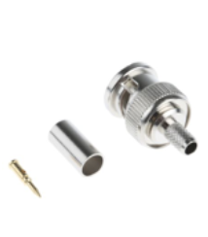

* + - * + Bayonet Neil-Concelman (BNC) coaxial connectors are used for quick connection or disconnection in RF equipment, test instruments, radio, television, and video signal.
  + **TNC Connector:**

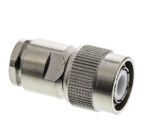

* + - * + The Threaded Neill-Concelman (TNC) connectors are small, weatherproof products which operate up to 12GHz. They’re often used in mobile phone and RF/antenna connections.
  + **SMB Connector:**

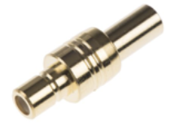

* + - * + Subminiature version B (SMB) connectors are one of the most popular RF/microwave connectors for industrial and telecommunications equipment – offering a simple snap-on coupling design for cables with uncommon connections.
  + **7/6 DIN Connector:**

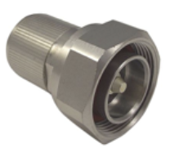

* + - * + The 7/16 DIN (Deutsches Institut für Normung) connector is a threaded RF connector used to connect coaxial cables.
        + These connectors are mainly used for applications which require water resistance, as they’re robust and durable. They’re particularly useful for base stations and broadcast communication systems.
  + **QMA Connector:**

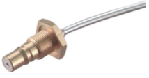

* + - * + QMA connectors are coaxial radio frequency connectors. They maintain the shielding barrier in electrical applications and feature snap-on mechanisms. They’re ideal for industrial and communications settings.
  + **MCX Connector:**

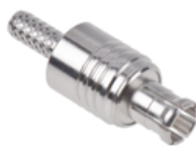

* + - * + Micro coaxial (MCX) connectors are ideal for environments restricted in size or space.
        + MCX connectors operate between DC and 6GHz in wireless, GPS, TV tuner cards, RF hardware, and digital cellular applications. These connectors also have a snap-on coupling design for easy installation.

1. **Fiber Optic Cable Connectors**

* There are four common elements of a fiber optic connector. These elements are:
  + **Ferrule**
  + **Body**
  + **Coupling**
  + **Core**

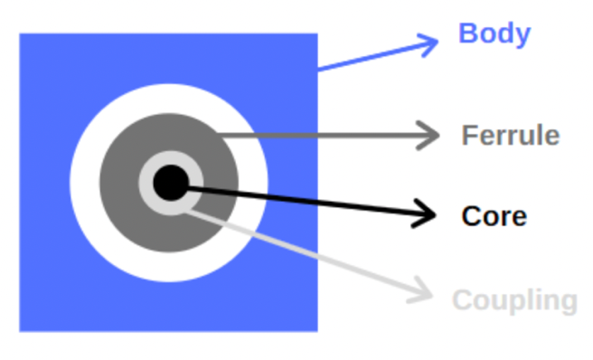

* The Ferrule is the structure that covers the fiber.
* The Body is the cover that protects the fiber.
* The Coupling is the cover that prevents signals in the core from escaping.
* The Core is the exact conduit part of the fiber that light passes through.
* Types of Connectors:
  1. **SC Connector:**

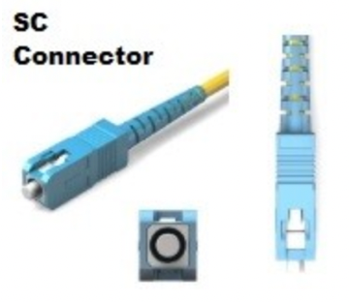

* SC (Subscriber Connector) is used on MMF or SMF. It is developed by Japon NTT . The mechanism used with SC Connector is push on/off mechanism. It is rerely used in todays network World. Instead of SC Connector, LC and MTP Multi Fiber networking connectors are used.
  1. **ST Connector:**

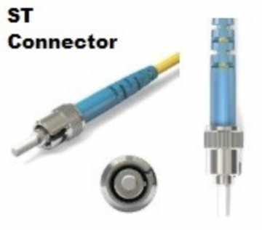

* ST (Straight Tip Connector) is the first connector type used for fiber optic termination at the end of multi mode cables. It is developed by AT&T. ST Connector is used with twist on/off mechanism. It is rerely used in todays network World. Instead of ST Connector, LC and MTP Multi Fiber Connectors are used.
  1. **LC Connector:**

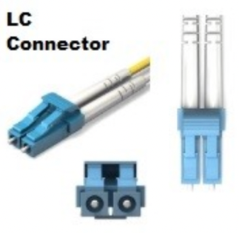

* LC (Lucent Connector) is a widely used SFF (Small Form Factor) networking connector used for high-density connections. LC Connector is consist of two fibers connected together at the same time and it is always duplex. It is developed by Lucent Technologies.

## Give cross-wired cable and straight through cable diagram (Color Code wise).

1. **Cross-wired Cable Diagram (Color Code)**

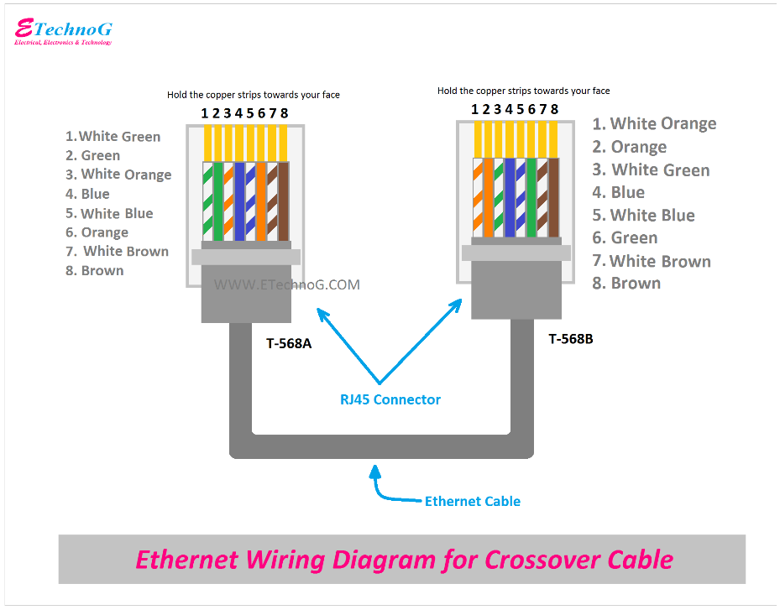

1. **Straight Through Cable Diagram (Color Code)**

